CREATE DATA FLOW FOR LOADING THE DATA IN SQL SERVER TABLE

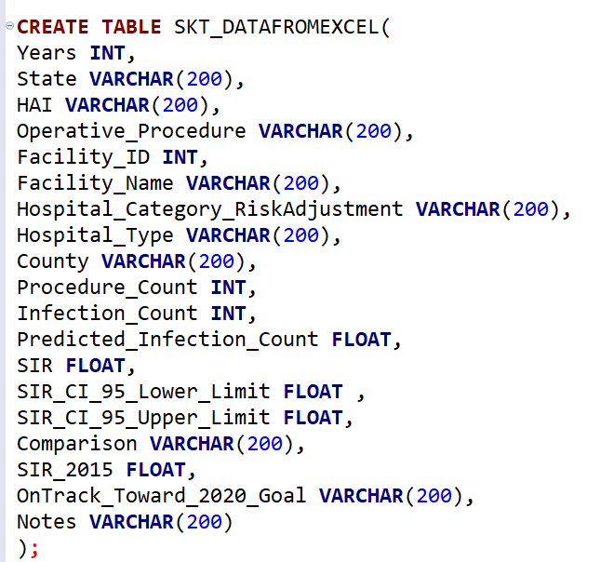

Executed



